Electronics
&
Semiconductors
from chem
it I have an isol and a conf
F
tithippen't
were not no n about it
what's special
needs another element of si I at changes from orbit to surface
1 Dr. Munirah Boufarsan, Eng. Ahmad Hayssam

Energygoes from one level to another
ifit couldn't
e can't go from one to another
diff between two levels big gap
what if the levels overlap conductor

Classification of Solids and Energy Bands
In solid-state physics: The valence band and conduction band are the bands that determine the electrical conductivity of the solid.
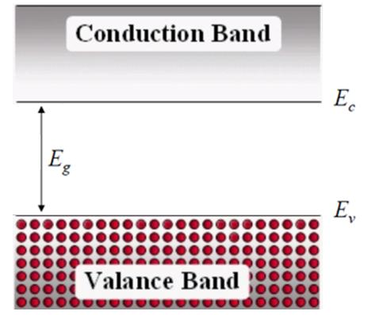

each level has IT_
on is a Volt value g
PIE
ionnection as
1 Eg is really big isol
herwise itcould start conducting thereare orbit 31 is
somany levels here
In non-metals: The valence band is the highest range of electron energies in which electrons are normally present at absolute zero temperature, while the conduction band is the lowest range of vacant electronic states.
2
Dr. Munirah Boufarsan, Eng. Ahmad Hayssam

semiggbags but if we dope it it'll have high charge to conduct
Classification of Solids and Energy Bands
Eg is the called the bandgap energy of the solid. It is measured in electron-volt (e.v).
unit
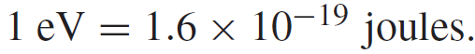

fort energy inside a material
Eg is called also the forbidden band because electrons are not allowed to be that energy level.
Eg is the energy separation of the conduction and valence band.
we can define whether the material is iso or cord based on thegap
The solid are classified as Insulator or Semiconductor or Metal according to Eg
3
Dr. Munirah Boufarsan, Eng. Ahmad Hayssam

Classification of Solids and Energy Bands
and could overlap in the 1
case of a perfect con d
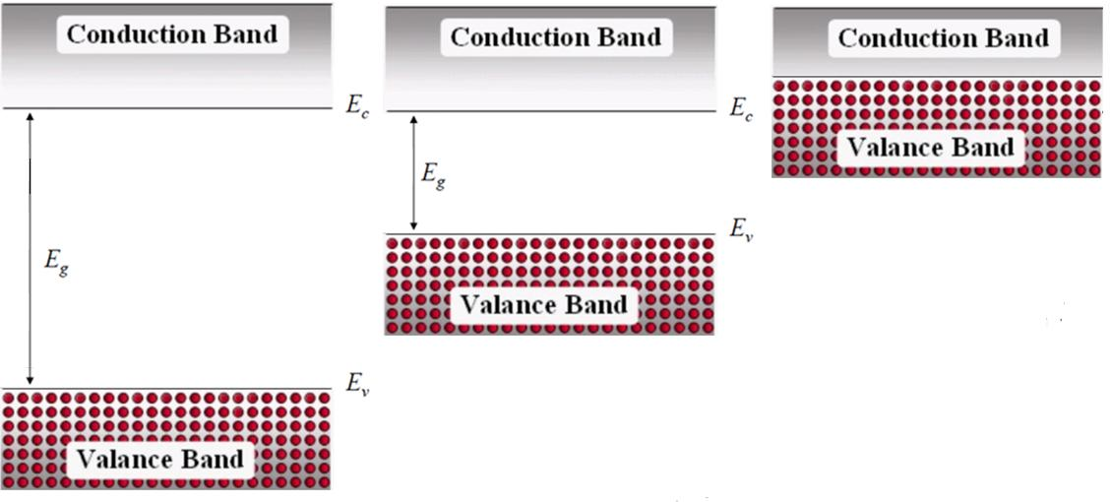

Insulator
Metal
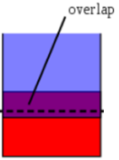

Semiconductor
4
Dr. Munirah Boufarsan, Eng. Ahmad Hayssam

Classification of Solids and Energy Bands
Isolators has Eg range of 3 to 6 (eV), are insulators because and at room temperature, essentially no free electrons exist in the conduction band.
In contrast, materials that contain free electrons at room temperature are conductors.
In a semiconductor, the bandgap energy is on the order of 1 eV.
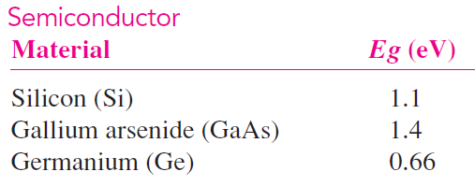

constants
5
Dr. Munirah Boufarsan, Eng. Ahmad Hayssam

Intrinsic Semiconductors
Feedctenoimparities when do we have this
at room temp
Intrinsic Semiconductor means No impurities or defects
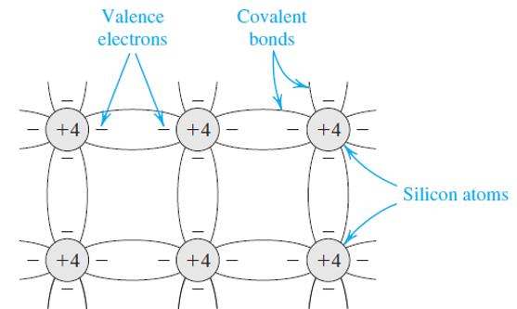

No charge carriers at T= 0 o K
n = p = 0 /cm 3
n # of electron/cm 3
p # of holes/cm 3
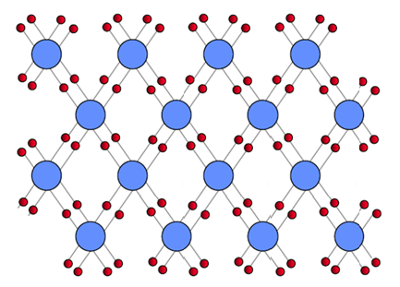

Si Atom
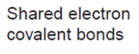

No free charge carriers
Dr. Munirah Boufarsan, Eng. Ahmad Hayssam
6

Intrinsic Semiconductors
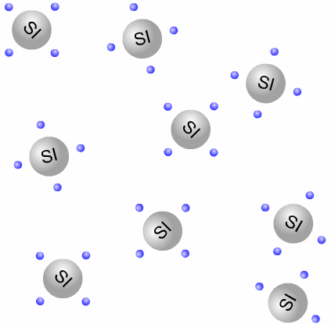

7
Dr. Munirah Boufarsan, Eng. Ahmad Hayssam

Intrinsic Semiconductors
No free charge carriers
At T= 0 o K
Empty States (No Carriers)

Current can only flow when there are allow carrier movement
Energy Gap
Filled States
only happens in two cases
I add sharge friite E
8
Dr. Munirah Boufarsan, Eng. Ahmad Hayssam

Intrinsic Semiconductors
As temperature increases, Generation and Recombination
of free E-H carriers will occur
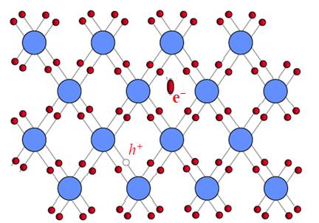

9
Dr. Munirah Boufarsan, Eng. Ahmad Hayssam

Intrinsic Semiconductors
As temperature increases, Generation and Recombination
of free E-H carriers will occur
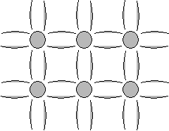

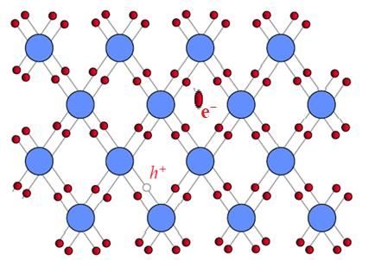

Free Electron (Carriers)
n o = p o
Vacant State
initially in
in Valence
the material
Band
before I
10
Dr. Munirah Boufarsan, Eng. Ahmad Hayssam

Intrinsic Semiconductors
As temperature increases, Generation and Recombination
of free carriers will occur
• EHP generation = EHP recombination
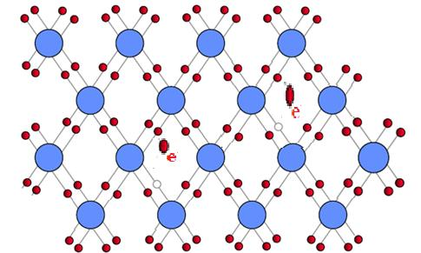

Recombination rate r r
Generation rate g i i
i
rate of yen always
g i
rate of recom
11
g i (T) = r i (T) Increases with temperature Dr. Munirah Boufarsan, Eng. Ahmad Hayssam

` Intrinsic Semiconductors
Band Structure at Room Temperature(300 o K)
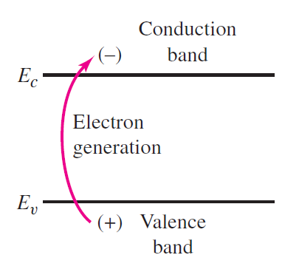

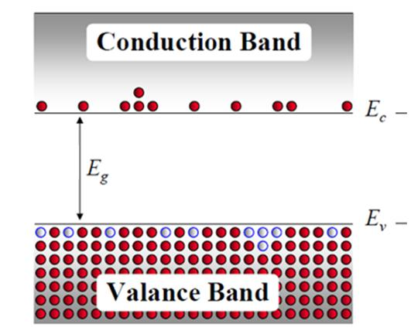

Empty States (Electrons)
of e here
p
Empty States in the valence band can be treated as Positively charged particles with positive mas called “ holes ”
of heat
Empty States
(Holes)
12
Dr. Munirah Boufarsan, Eng. Ahmad Hayssam

what does hen
Intrinsic Semiconductors
At Room Temperature (300 o K) `
• n o = equilibrium concentration of electrons
• p o = equilibrium concentration of holes
• n o = p o = n i = ( 1.5x 10 10 cm -3 in Si at 300 o K)
0 of free e
• n i is called the intrinsic carrier concentration
2 at any Temperature
n o p o = n i
13
Dr. Munirah Boufarsan, Eng. Ahmad Hayssam

Intrinsic Semiconductors
• n i = intrinsic carrier concentration
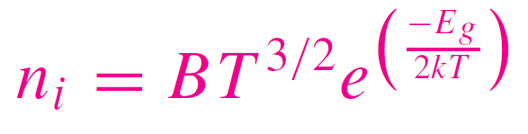

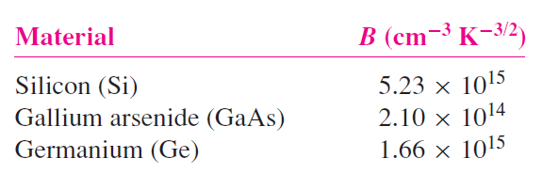

14
Dr. Munirah Boufarsan, Eng. Ahmad Hayssam

Example 1
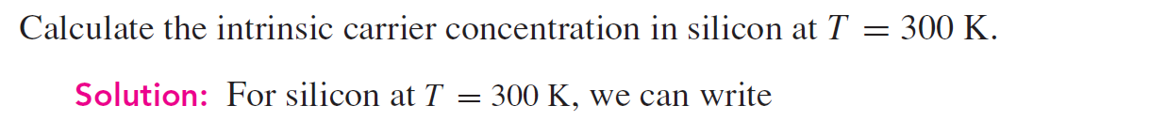

B from what the
material is
comet K 8 6 70 s
Eg 7.7
ni BT Ét 5.23 10 s 300 e t.at no yJ
or
ni 1 5 1010 1cm
An intric elec concent of 1.5 101 cm may appear to b large but it's relatively small compared to the concent of si atoms which is s 1072 Cm's
15
Dr. Munirah Boufarsan, Eng. Ahmad Hayssam

5 1
ext conduct
Intrinsic Semiconductors
9.5
doping g
Band Structure at Room Temperature(300 o K)
holes concen
jess
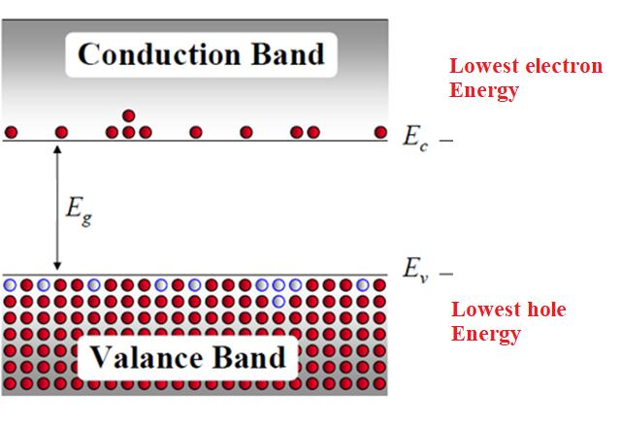

Higher electron Energy
Higher Hole Energy
16
Dr. Munirah Boufarsan, Eng. Ahmad Hayssam

Extrinsic Semiconductors
i 614 D
impur
• Impurities introduced by doping
• Doping allows the creation of extra carriers
min is
n o ≠ p o ≠ n i
Isis
• n-type material (electron carriers)
sooner
24
Column V donor impurities Nd (P, As, Sb) n o >> p o , n i
on
• p-type material (hole carriers)
Column III acceptor impurities Na (B, Al, Ga, In)
so
p o >> n o , n i
17
Dr. Munirah Boufarsan, Eng. Ahmad Hayssam

Extrinsic Semiconductors
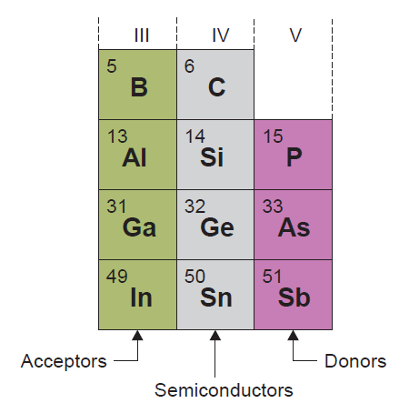

Impurities
impatistien
Nd N-Type Na P-Type
18
Dr. Munirah Boufarsan, Eng. Ahmad Hayssam

Extrinsic semiconductors
Nd Donor Na Acceptor
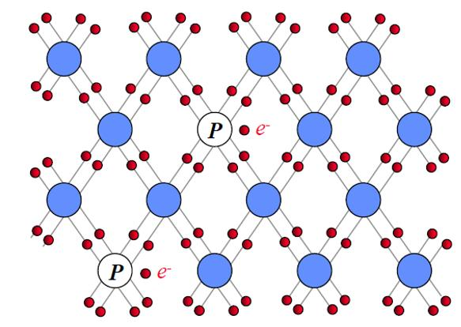

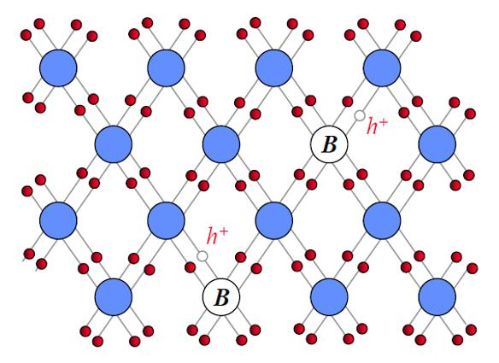

0 a
n-Type p-Type
19 Dr. Munirah Boufarsan, Eng. Ahmad Hayssam

n-type Semiconductor
energyst its
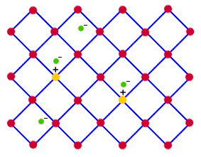

gap
20
Dr. Munirah Boufarsan, Eng. Ahmad Hayssam

n-Type Semiconductors
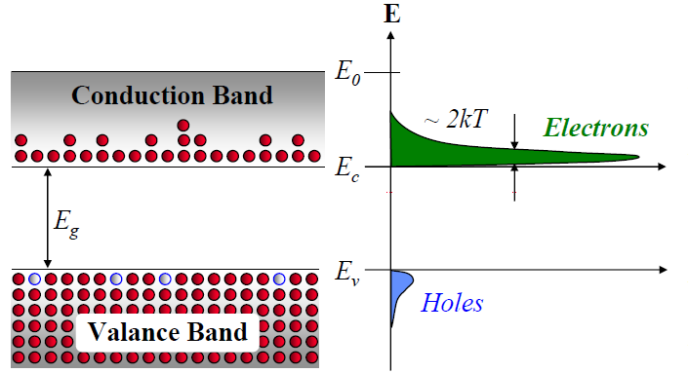

n o >> p o , n i
Free Electrons
n
Tweet
21
Dr. Munirah Boufarsan, Eng. Ahmad Hayssam

n-Type Semiconductors
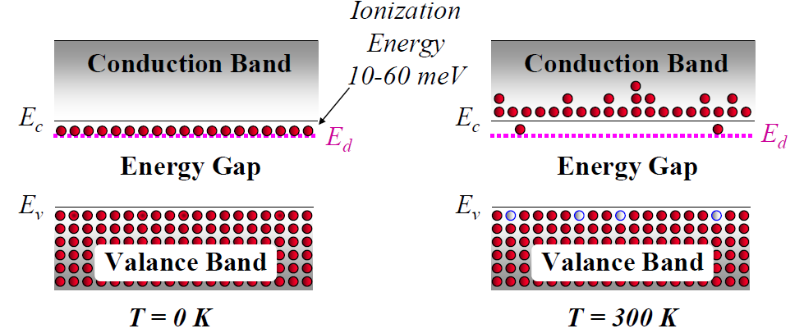

22
Dr. Munirah Boufarsan, Eng. Ahmad Hayssam

p-Type Semiconductors
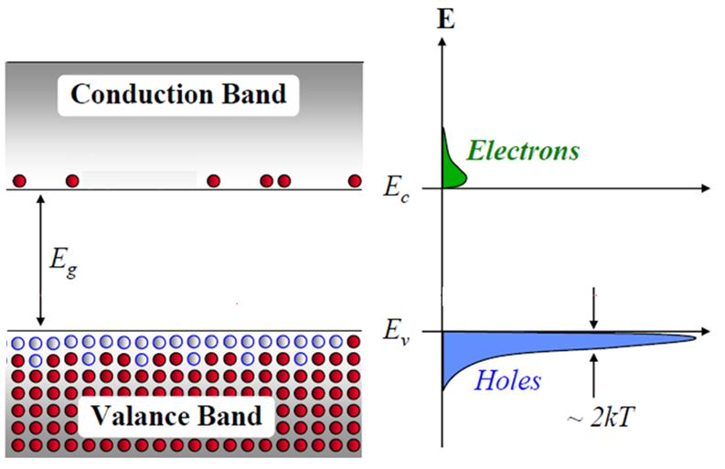

23 p o >> n o , n i
Dr. Munirah Boufarsan, Eng. Ahmad Hayssam

p-Type Concentration
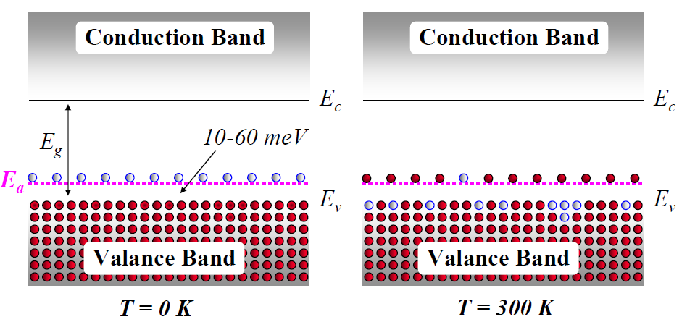

24 Dr. Munirah Boufarsan, Eng. Ahmad Hayssam

Extrinsic Semiconductors
n type
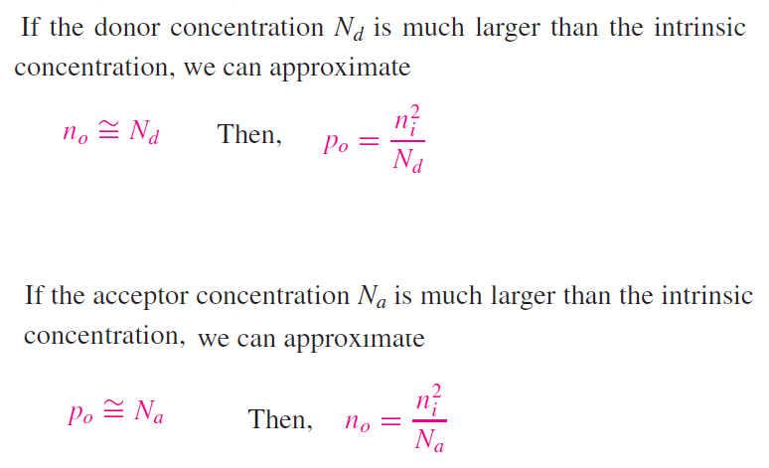

np n.I­N
if we know the majority
we'll be able to find
the minority
25
Dr. Munirah Boufarsan, Eng. Ahmad Hayssam

Example 2
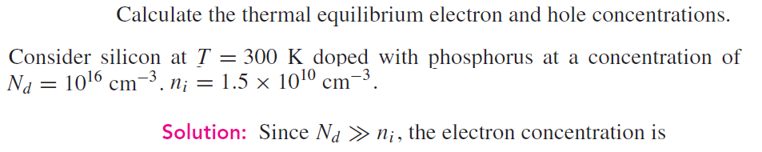

since Na ni the elee conc is
no Nd 10 161cm n Nd 7 ni
p nifty
2 25 10 am

26
Dr. Munirah Boufarsan, Eng. Ahmad Hayssam

Example 3
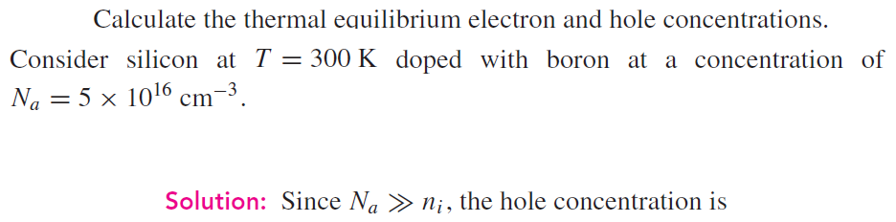

Po I Na 5 10 16 cm
and the elec conc is
no hip
4 5 103 cm
27
Dr. Munirah Boufarsan, Eng. Ahmad Hayssam

Compensated Semiconductor
A compensated semiconductor is one that contains both donor and acceptor impurity atoms in the same region. We classify the compensated semiconductors as
Finthe same
1- An n -type compensated semiconductor occurs when Nd > Na
2- A p -type compensated semiconductor occurs when Na > Nd
3. If Na = Nd , we get completely compensated semiconductor that has the characteristics of an intrinsic material
semicond
28
Dr. Munirah Boufarsan, Eng. Ahmad Hayssam

n-Type Compensated Semiconductor
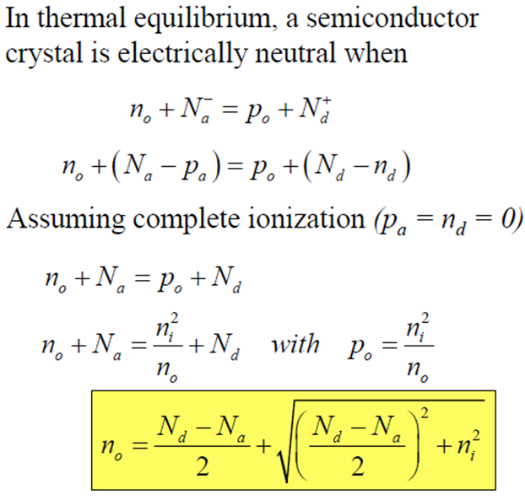

-
-
n-Type If only N d
Set N a =0
29
Dr. Munirah Boufarsan, Eng. Ahmad Hayssam

p-Type Compensated Semiconductor
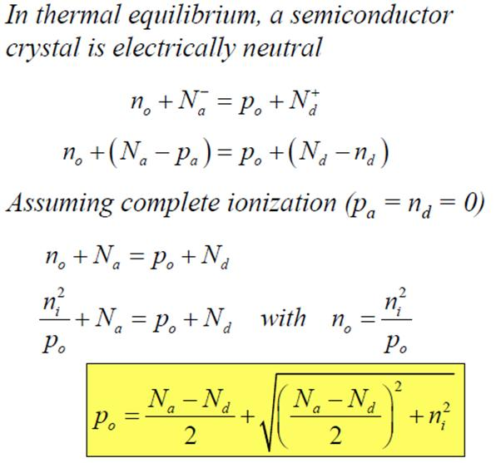

p-Type If only N a
n If
Set N d =0
30
Dr. Munirah Boufarsan, Eng. Ahmad Hayssam

Compensated Semiconductor Example 4
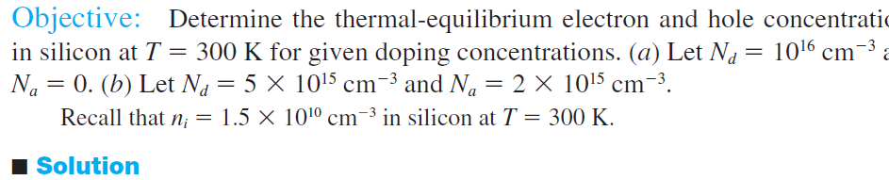

a the maj carr elec conc is
no 1 É5xtT 1014am
The min carrier hole conc.is found to be
p if 1.5 10 3 L Po 7 5 10 cm
31
Dr. Munirah Boufarsan, Eng. Ahmad Hayssam

Compensated Semiconductor Example 4
32
Dr. Munirah Boufarsan, Eng. Ahmad Hayssam

Example 5
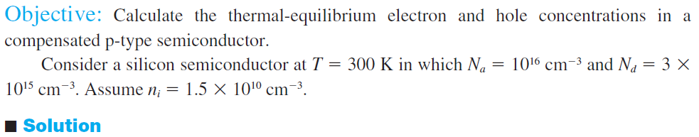

Na Fptyp
major p
P 7 10 s cm
no ls.tt s iog
33
Dr. Munirah Boufarsan, Eng. Ahmad Hayssam

Example 5
34
Dr. Munirah Boufarsan, Eng. Ahmad Hayssam

